Project 2_Foreigners

Team Members: Kavya Shabnavees; Yan Xu; Michel Maniguet; Vladislav Titov

Team Name - AirbnbAustin

Data source website:<http://insideairbnb.com/get-the-data.html>

Data Type: CSV [listings.csv](http://data.insideairbnb.com/united-states/tx/austin/2019-05-14/visualisations/listings.csv)

Topic:

Our project is to visualize different parameters from Airbnb listings based on their Zip Codes.

DataSet:

The CSV file contains Host_ids, latitude and longitude info, room type, price etc.

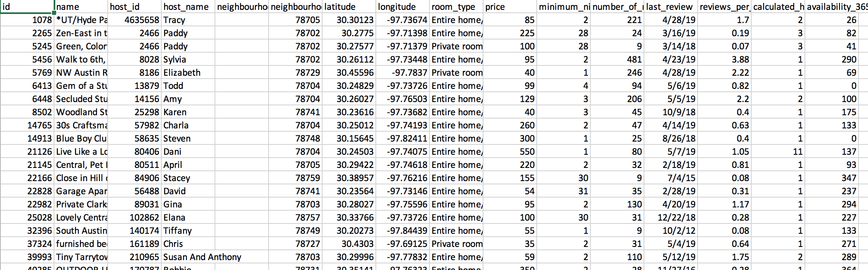

Inspiration:

In an attempt to find and visualize best places to consider in specific areas around Austin, we chose this topic.

Visuals:

1. Multiple BarCharts:

Top 10 listings/Zipcode/RoomType based on Reviews or Price parameters

2. Scatter Plots: No. of listings/Zipcode

3. Leaflet Map: Price of listings/Zipcode with popup.

Following are a few questions that we aim to answer through our analysis:

* How do prices of listings vary by location?
* What localities in Austin are rated highly by guests?

Github link:<https://github.com/yanzi1210/project2_AirbnbAustin>

Note:

We will store the data in SQL and use Plotly to extract it.

We will try to visualize the data something like below: